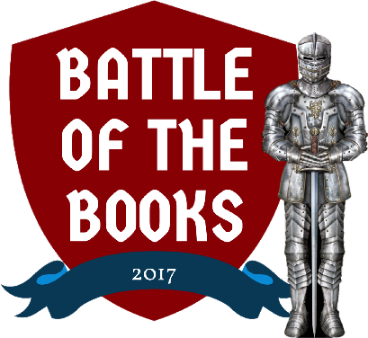
Coach’s Overview

What is BoB?
Battle of the Books (BOB), a program for fourth, fifth and sixth grade students, is designed to promote reading. BOB is an extracurricular, after-school quiz competition that features questions from a list of ten books selected by librarians to interest a wide variety of readers. During the battle season, participants will read and meet with their teammates to talk about books while building camaraderie and a spirit of competition. Through these activities kids reap the rewards of reading and working as a team, while having a lot of fun!!
Who participates?
Teams from the Houghton Lake Public, Ardis Missaukee District, McBain Community, Otsego County and the Roscommon Area District Libraries will compete against each other to claim the Battle of the Books 2017 Championship and have the honor of hanging the traveling plaque in their home library!
What does a coach do?
Being a BOB team coach is a very important job. Each coach is assigned a team of four or five children and holds regular team practices to help readers stay motivated and on track. Coaches assist readers in dividing up book reading responsibilities and also provide ideas to help the team be successful. Most importantly, coaches work toward making BOB a fun, positive experience. Coaches must attend the kick-off event at the library on Jan. 14th, where they will meet their teams, select a team name, design a logo for team t-shirts, and obtain a set of books for reading.
Although every team will not make it to the final battle, having fun as a team and participating in voluntary reading will last long after the program ends. There are many ways to accomplish this, regardless of how far your team goes in the battles. Win or lose, all coaches and teams are encouraged to attend the exciting final Battle of the Books Championship Battle on March 18th at the Houghton Lake High School Auditorium.

Coach Responsibilities:
- Attend all meetings and battles with your team:
  - Jan. 14th @11am - Kickoff! Meet coaches, form teams, get books, create team logos.
  - Feb. 11th @11am First mock battle using five books
  - Feb. 25th @11am Second mock battle using all ten books
  - March 11th @11pm Library Championship / Elimination Battle
  - March 18th @1pm Battle of the Books 2017 Championship!

- Plan and attend additional meetings with your own team to strategize and encourage readers. These meetings may be planned at your convenience. Keep track of your team’s progress by meeting with them regularly. The library is the best place to meet – the library’s community meeting room may be reserved free of charge by a team coach.

- Let your team members and their parents know what you expect of them in terms of reading and commitment.

- Encourage each team member to read as many books as possible. Some coaches may divide the books making each team member responsible for certain books.

- Use the “Team Reading” chart, which has the book titles down the side and spaces for your team member’s names across the top, to track which team members have read which books. As each member finishes a title, mark the appropriate spot. This chart is provided in the coach’s packet.

- Keep track of who has each book and be sure the entire 10 book set is returned to the owning library on elimination day (March 11th) and after the final battle (March 18th).

- Keep a notebook of questions for all of the books with the main characters, the important events, the settings, etc., listed below each title.

- During your meetings, encourage your team to keep reading, practice quizzing each other and to practice writing down the answers. Promote the fun of reading and the satisfaction that comes from a commitment to a team. All of this will help your team during the competition!

- Although it’s not required, you might enjoy reading some of the books yourself!
Note: Coaching volunteers must consent to a criminal background check by providing their name [first, last and middle initial], gender and date of birth.
Questions? Concerns?
Contact Diane Eisenga - 824-2197 or Laura Marion – 839-2166

